© ABB Limited 2005
This document contains information that is confidential. It must only be used for the agreed purpose for which it is provided. The contents of this document must not be reproduced or distributed in whole or in part without the written consent of ABB Limited or its authorised representatives.

Title | Access Right Management in the Common Framework:  Subsystem Subsystem Requirement Specification
Distribution | Software Archive
Author | Peter Vince |  | Date | 2006-05-08
Review | Software Architect | Nick Malcolm | Date | 2006-05-08
Approved | Software Architect | Nick Malcolm | Date | 2006-05-08
Approved | Project Leader | Ray Keech
Remarks | Review was conducted in two stages, on 13/01/2006 and 16/01/2006. The review document can be found on Sharepoint.

Contents

1 Introduction 3
1.1 Scope 3
1.2 Document Conventions 3
1.3 Definitions 3
1.4 Acronyms and Abbreviations 4
2 Overall description 5
2.1 Product Perspective 5
2.2 System Structure 5
2.3 Operating Environment 5
2.4 Design and Implementation Constraints 5
2.5 Assumptions and Dependencies 6
2.6 Use Case Overview 6
3 Functional Requirements 7
3.1 General 7
4 Non-Functional Requirements 11
4.1 Performance 11
4.2 Safety 11
4.3 Security 11
5 ARM Subsystem Memory requirements 12
6 ARM Requirements / Cross-Reference with Systems Requirements 13
6.1 Cross-Reference with EMF requirements 14
6.2 Cross-Reference of Complexity versus ARM requirements 15
Revision History 16
References 16

List of Figures

Figure 1: ARM Subsystem Use Case Diagram 6

Introduction

Scope

Purpose of this requirement specification is to define the minimal set of requirements the access rights management (ARM) handler in the common framework has to provide to be useful for the different products developed in the scope of Process5k. Therefore requirements from the different R&D-Teams were collected and presented in this specification.

It is not intended to have only one type of access rights management. Different devices may have different levels of access rights, may have a custody switch or not etc. The intention is that the framework provides a mechanism that allows different realizations without requiring adoptions in the clients of the ARM such as the HMI, HART, Fieldbus, and even device specific interfaces used for configuration in the factory.

Document Conventions
Software Requirements are identified using the following in-line table format:

Ident. | Definition / Motivation | Priority  Mandatory | Source
 |  | Stability  Not agreed | Source

Ident. a unique identifier for the Requirement
Priority one of: Mandatory / Desirable / Future
Stability one of: Committed / Not Agreed / Likely to Change
Source one of: R&D / D&D Lenno / Alzenau / Stonehouse / Minden / Göttingen / St.Neots / All

Definitions

Term | Definition
Access Rights Manager | This subsystem (ARM). It has the responsibility to grant or deny access for reading or writing any object (and/or its attribute(s)).
ARM client | Another subsystem that wants to change the device configuration and uses the ARM to check if access is granted or not. Typical clients are HMI, HART, Fieldbus and specific interfaces for factory configuration.
Access Rights Table | Table of access rights for each configurable or readable item (given in terms of target subsystem id, object id, and attribute id). The access-rights are indicated per user-level (ie: Basic, Standard, Advanced, Service) as to whether they are: invisible, read-only, read/write. Each Client subsystem (eg: HMI, HART, etc) holds its own Access Right Table within its own subsystem.
Custody Switch | A hardware jumper that permits configuration changes to selected parameters only.
Device Subsystem | Subsystem responsible for handling Transmitter ID and PIN.
Fieldbus | The Fieldbus® protocol. This incorporates Fieldbus protocols like Fieldbus Foundation, Profibus PA, Profibus DP
HART Subsystem | Subsystem responsible for interfacing to HART protocol communications.
HMI Subsystem | Subsystem providing HMI for local user access via display and key input.
Read Only Switch | A hardware switch that makes all objects that normally are available at the current access level, read-only.

Acronyms and Abbreviations

ARM | Access Rights Manager or Management.
HART | Highway Addressable Remote Transducer
HMI | Human Machine Interface

Overall description

Product Perspective

The concepts for handling access rights will be used in all products based on the Common Framework. The ARM subsystem should cover the requirements for the upcoming flow devices developed in the EMF project ([1], [2], [3]), the pressure and temperature devices developed in UHTE, and all upcoming devices developed in the scope of Process5k.

System Structure

The ARM should be used in the following type of systems:

Complex: The system supports many different levels of user groups with different access rights. Depending on the user group the HMI may display or hide whole frames, variables within a frame and may allow or disallow changing of a variable depending on the group.

Simple: The system supports none, or only one user group and may or may not have a password.

Operating Environment

M16C/M32C from 2MHz … 24MHz
Two wire low power devices
Four wire devices

Design and Implementation Constraints

Process: The software process described by the ABB Corporate Research project Process5K is to be used for the development.

Diagram Tools: UML UseCase / State Chart / and Collaboration diagrams will be drawn using the Gentleware Poseidon UML tool specified by Process5K.

Programming Language: IAR C

Related Common Components: - HMI [7]. The ARM influences the design of some HMI frames. This
is further detailed in Security Access Interface for Instrumentation
Products.
- HART
- SFD
- Common Framework [5], [6][5][5]

Assumptions and Dependencies

Real-time operating System EmbOS from Segger will be used as it is defined as basis for the common framework.

Use Case Overview

For all uses-cases, see Figure 1: ARM Subsystem Use Case Diagram. For use-case descriptions, see .

Figure 1: ARM Subsystem Use Case Diagram

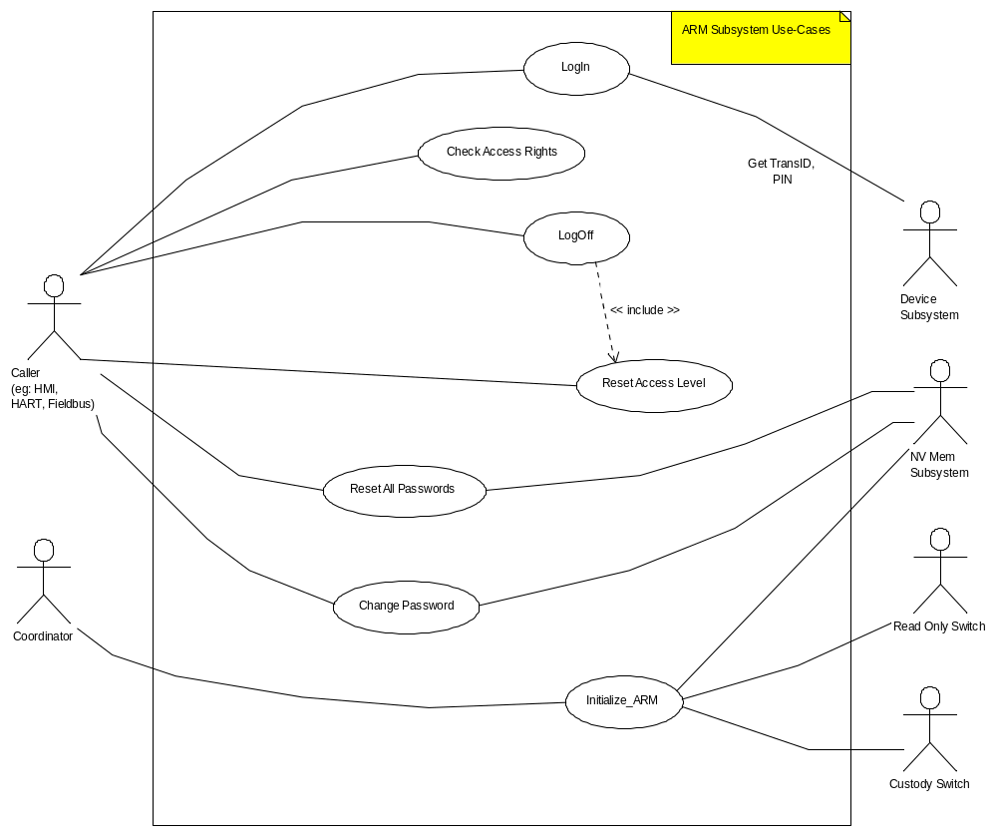

Functional Requirements

General
Ident. | Definition / Motivation | Priority  Mandatory | Source  All  D&D Stonehouse  R&D Göttingen
FR-G1 | The ARM must be able to distinguish between different user groups; each has a different access level. There may be up to 4 selectable levels of access:  Basic (Read Only);  Standard;  Custody Switch Level: (not user selectable, see FR-G1.1)  Advanced;  Service;  However, simple systems may use only a subset of the above, for instance with just 2 or 3 levels. | Stability  Agreed by EMF | Source  All  D&D Stonehouse  R&D Göttingen
FR-G1.1 | There are different configuration possibilities at different access levels:  Basic (Read Only): no password required; some objects readable; no objects are configurable.  Standard: simple password required; additional readable objects; some objects configurable, provided the Read-Only switch is disengaged.  Custody Switch Level: a reduced-access variation of the Standard user; a user can only login at this level when the custody-switch is engaged.  Advanced: simple password required; further readable objects; further objects configurable, provided the Read-Only switch is disengaged.  Service: simple/hashed password required; all objects readable; all objects configurable, provided the Read-Only switch is disengaged. | Stability  Agreed by EMF | Source  All  D&D Stonehouse  R&D Göttingen
FR-G1.2 | Each User Level (defined in FR-G1) shall have a Password Access Level associated with it. Each Subsystem Data object/attribute shall have a corresponding Password Access Level associated with it. | Stability  Agreed by EMF | Source  All  D&D Stonehouse  R&D Göttingen
FR-G1.3 | The ARM can behave differently depending on which Client Subsystem (HMI, HART, etc) is calling the ARM. | Stability  Agreed by EMF | Source  All  D&D Stonehouse  R&D Göttingen

Ident. | Definition / Motivation | Priority  Mandatory | Source  All
FR-G2 | The access rights of a higher user group include all the rights of the lower user group. | Stability  Agreed by EMF | Source  All

Ident. | Definition / Motivation | Priority  Mandatory | Source  All
FR-G3 | Based on the user group it should be possible to specify the following access rights for each object: Read-Write, Read-Only, Invisible; eg: for a particular object of a subsystem:  Standard Level: Invisible  Advanced Level: Read Only  Service: Read/Write | Stability  Likely to change | Source  All

Ident. | Definition / Motivation | Priority  Mandatory | Source  All
FR-G4 | It should be possible to enable/disable configuration changes for a specific ARM client.  E.g. a device wants to implement a feature that local configuration can be switched on and off from the control system via remote communication. | Stability  Agreed by EMF | Source  All

Ident. | Definition / Motivation | Priority  Mandatory | Source  All
FR-G5 | It should be possible to concurrently access the device from different user interfaces, eg: HMI, at the same time as HART. | Stability  Agreed by EMF | Source  All

Ident. | Definition / Motivation | Priority  Mandatory | Source  All
FR-G6 | No timeout for automatic logoff is provided. This should be handled directly in the ARM clients such as HMI, HART, etc. if required. | Stability  Agreed by EMF | Source  All
FR-G6.1 | At power-down all log-ins are lost. Thus each ARM client has to login again after a Power-on. | Stability  Agreed by EMF | Source  All

Ident. | Definition / Motivation | Priority  Mandatory | Source  All  D&D Stonehouse  R&D Göttingen
FR-G7 | The ARM has the responsibility of handling the Custody Switch, and will restrict configuration options to a defined number of objects when the switch is active. | Stability  Agreed by EMF | Source  All  D&D Stonehouse  R&D Göttingen
FR-G7.1 | It should be possible to interrogate the state of the Custody Switch. | Stability  Agreed by EMF | Source  All  D&D Stonehouse  R&D Göttingen
FR-G7.2 | The ARM has the responsibility to handle the Read-Only Switch and will deny configuration changes if active. | Stability  Agreed by EMF | Source  All  D&D Stonehouse  R&D Göttingen
FR-G7.3 | It should be possible to interrogate the state of the Read Only Switch. | Stability  Agreed by EMF | Source  All  D&D Stonehouse  R&D Göttingen

Ident. | Definition / Motivation | Priority  Mandatory | Source  D&D Stonehouse  All
FR-G8 | Password Protection I Types (Customer protection code)  Password Protection I  Simple password (code) to access Standard and Advanced configuration level.  Password Protection II  Initially: Fixed Service level password;  Future: Protecting access to parameters via a hashing mechanism (PIN, Serial Number) to access Service level. | Stability  Agreed by EMF | Source  D&D Stonehouse  All
FR-G8.1 | The simple Password string shall consist of 1 to 5 alpha numeric characters. | Stability  Agreed by EMF | Source  D&D Stonehouse  All
FR-G8.2 | Future: The Hashed Password string shall consist of 5 hex-numeric characters (0-9,A-F) only. E.g. “0F3A7”, “FACBA”, “23754”  The Service User Class requires a more secure Hashed Password mechanism to obtain Access. | Stability  Agreed by EMF | Source  D&D Stonehouse  All

Ident. | Definition / Motivation | Priority  Mandatory | Source  All  D&D Stonehouse  R&D Göttingen
FR-G9 | The ARM has to support changing of passwords. | Stability  Agreed by EMF | Source  All  D&D Stonehouse  R&D Göttingen
FR-G9.1 | The ARM has to support resetting the customer passwords for Standard and Advanced level without logging into the Service level. | Stability  Agreed by EMF | Source  All  D&D Stonehouse  R&D Göttingen
FR-G9.2 | The ARM has to support null passwords for standard and advanced level. Thus, the user does not need to enter a password to enter the standard and advanced level. | Stability  Agreed by EMF | Source  All  D&D Stonehouse  R&D Göttingen

Ident. | Definition / Motivation | Priority  Mandatory | Source  All
FR-G10 | High Security Configuration Flag  A configurable flag is required which is used to indicate if a high security feature is enabled or not.  i) When high security feature is “off”, use fixed service level password.  ii) When high security feature is “on”, the hasher will be used for service level access.  Configuring this flag requires special configuration  By default the high security is off. The customer can turn this flag on, but cannot turn it off without a Hash code.  Note: (i) is the only initial option. (ii) for future options | Stability  Agreed by EMF | Source  All

Non-Functional Requirements

Performance

It should be noted that for some implementations using the ARM, the memory model might be compact. This means that a large amount of memory cannot be made available for a large Access Right Table.

To this end, a complex system may use all the features described in section 3 in order to generate a large Access Right Table, per Client Subsystem; giving full access descriptions based on the maximum number of user-access levels, and for each subsystem object individually.

Similarly, a simple system may choose to reduce the optional features from section 3 to the bare minimum, thereby creating a much smaller Access Right Table which caters for all Client Subsystems, and granting access rights for just one or two user-access levels, and for all or some subsystem objects collectively.

Safety

Security

It has been identified in “OIML_R049-1-e03_ColdPotableWater” [9][9][9], section 5.8.3.1 (for WW version) and “OIML_R117-e95_LiquidsOtherThanWater” [8], section 2.20.2 (for IND version) that memory-records of previous operator access are NOT required IF a mechanical sealing device is provided on the instrument/device.

If this is not the case (that is, no mechanical seal provided), then any device using this subsystem will be responsible for providing traceable memory-records of at least the last operator intervention (to include the date and operator identity), which must be maintained valid for up to 2 years or until over-written by a subsequent intervention record.

As far as the ARM subsystem is concerned, it is a stated condition that any system using the ARM subsystem as a common component complies with the requirement that mechanical sealing devices are used within that system.

ARM Subsystem Memory requirements

The ARM Subsystem Requirements summary is TBD.

ARM Requirements / Cross-Reference with Systems Requirements

As this subsystem is intended to be a common component, requirements have been supplied from the various interested parties that are likely to use the ARM. The requirements contained in this document may therefore exceed the requirements for any particular system intending to use the ARM.

The sub-sections below are intended to indicate the correspondence between the requirements outlined in this documents and the specific requirements of named Systems.

Cross-Reference with EMF requirements

The following is a cross-reference of ARM Subsystem Requirements versus EMF Common Software Requirement Specification [1].

 | EMF System Common Software Requirements Specification Identity
ARM Common Component Identitiy  (this document) | NF-SEC 1 | NF-SEC 2 | NF-SEC 3 | NF-SEC 4 | NF-SEC 5 | NF-SEC 6 | NF-SEC 7 | NF-SEC 8 | NF-SEC 9 | NF-SEC 10 | NF-SEC 10A | NF-SEC 11 | NF-SEC 12 | NF-SEC 13 | NF-SEC 14 | NF-SEC 15
FR-G1 |  |  | x
FR-G1.1 |  |  |  |  |  |  |  |  |  |  |  | x
FR-G1.2 |  |  |  |  |  |  |  |  |  |  |  |  | x
FR-G1.3*
FR-G2 |  |  |  | x
FR-G3 |  |  |  |  | x
FR-G4*
FR-G5 |  |  |  |  |  | x
FR-G6 |  |  |  |  |  |  | x
FR-G6.1*
FR-G7 | x
FR-G7.1 |  | x
FR-G7.2*
FR-G7.3*
FR-G8 |  |  |  |  |  |  |  |  |  | x | x
FR-G8.1 |  |  |  |  |  |  |  |  |  |  |  |  |  |  | x
FR-G8.2 |  |  |  |  |  |  |  |  |  |  |  |  |  | x | x
FR-G9 |  |  |  |  |  |  |  | x
FR-G9.1 |  |  |  |  |  |  |  |  | x
FR-G9.2*
FR-G10 |  |  |  |  |  |  |  |  |  |  |  |  |  |  |  | x
* This feature has not previously been identified in the EMF Common Requirements Specification

Cross-Reference of Complexity versus ARM requirements

The following is a cross-reference of Simple/Complex builds ARM Subsystem Requirements[1].

 | ARM Complexity
ARM Common component Identitiy  (this document) | Simple  (Shows what applies as a minimum) | Complex  (Shows what applies as a maximum)
FR-G1 | Basic level | Basic, Standard, (Custody), Advanced, Service levels
FR-G1.1 | Basic level | Basic, Standard, (Custody), Advanced, Service levels
FR-G1.2 | Applies in respect of user levels defined | Applies in respect of levels defined
FR-G1.3 | Applies | Applies
FR-G2 | Applies if more than 1 user level defined | Applies in respect of levels defined
FR-G3 | Applies in respect of user levels defined | Applies in respect of user levels defined
FR-G4 | Applies | Applies
FR-G5 | Applies | Applies
FR-G6 | Applies | Applies
FR-G6.1 | Applies in respect of user levels defined | Applies in respect of user levels defined
FR-G7 | Applies if Custody Switch is fitted | Applies if Custody Switch is fitted
FR-G7.1 | Applies if Custody Switch is fitted | Applies if Custody Switch is fitted
FR-G7.2 | Applies if Read Only is fitted | Applies if Read Only is fitted
FR-G7.3 | Applies if Read Only is fitted | Applies if Read Only is fitted
FR-G8 | Applies in respect of user levels defined | Applies in respect of user levels defined
FR-G8.1 | Applies in respect of user levels defined | Applies in respect of user levels defined
FR-G8.2 | Applies if Service level defined | Applies where Service level defined
FR-G9 | Applies | Applies
FR-G9.1 | Applies if Standard/Advanced level defined | Applies where Standard/Advanced level defined
FR-G9.2 | Applies if Standard/Advanced level defined | Applies where Standard/Advanced level defined
FR-G10 | Applies if Service level defined | Applies where Service level defined
* This feature has not been identified in the EMF Common Requirements Specification

Revision History
Rev. | Description of Version/Changes | Primary Author(s) | Date
0.1 | Initial revision. Includes comments for requirements clarification. | Peter Vince | 2005-12-08
0.2 | Revised following Requirements review | Peter Vince | 2006-01-17
1.0 | Formal up-rev to issue 1.0 | Peter Vince | 2006-05-08

References
Ref. | Document
[1] | Common Software Requirements Specification  ABB EMF, Low Cost Water Waste & Industrial Transmitters  http://myportal.de.abb.com/sites/process5k/proj/emf/software/Scope/Common Software Requirement Specification.doc
[2] | Software Quality Plan  ABB EMF, Low Cost Water Waste & Industrial Transmitters  http://myportal.de.abb.com/sites/process5k/proj/emf/software/Management/Software Qualityplan.doc
[3] | Overall Software Design Description  ABB EMF, Low Cost Water Waste & Industrial Transmitters  http://myportal.de.abb.com/sites/process5k/proj/emf/Shared Documents/Software/Design/Design Description Software - System.doc
[4] | ARM Subsystem Use Case Descriptions  http://myportal.de.abb.com/sites/process5k/proj/emf/software/Subsystems/ARM/ARM Subsystem Use Cases.doc
[5] | Common Field Device Framework, Heiko Kresse  <<TBA on new Sharepoint Server>>
[6] | Data Classes.doc (section on Access Rights Management), Nick Malcolm  <<TBA on new Sharepoint Server>>
[7] | Security Access Interface for Instrumentation Products, Geoff Selley  <<TBA on new Sharepoint Server>>
[8] | OIML_R117-e95_LiquidsOtherThanWater  T:\396\Requirements\Standards or <<TBA on new Sharepoint Server>>
[9] | OIML_R049-1-e03_ColdPotableWater  T:\396\Requirements\Standards or <<TBA on new Sharepoint Server>>

